Step 1: download latest version from the following link (cloc 1.86.exe)

https://github.com/AlDanial/cloc

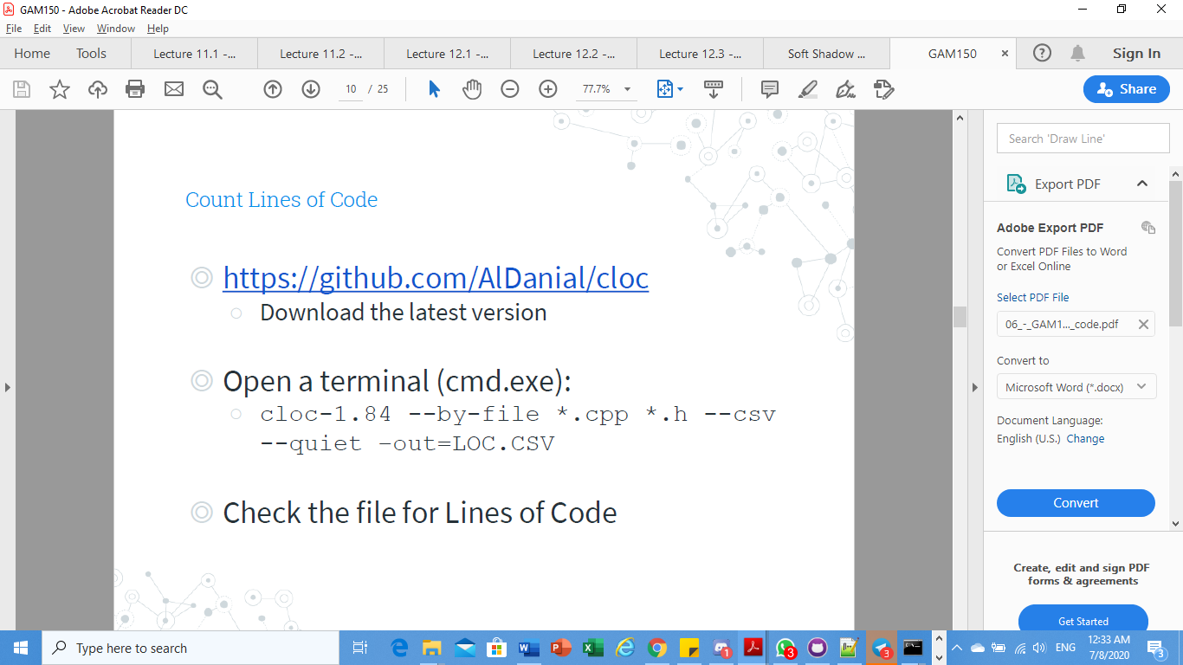

Step 2: Put the cloc-1.86.exe at where the .cpp and .h files are at.

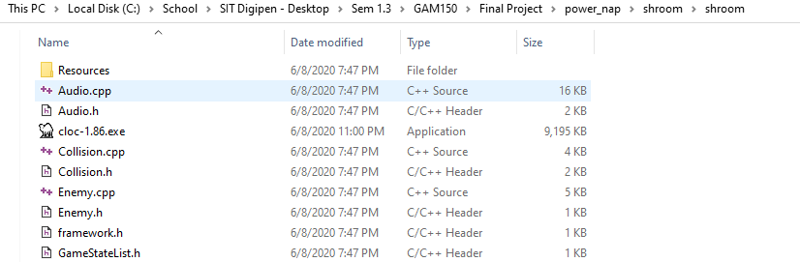

Step 3: under the same directory, type cmd and press enter.

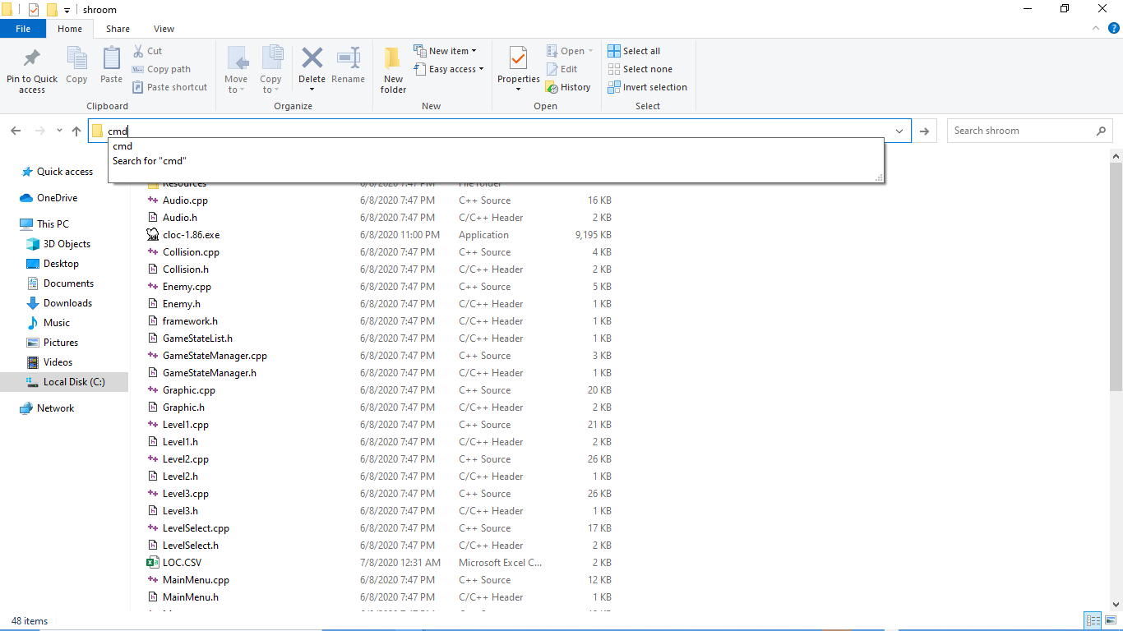

Step 4: insert the following command code

cloc-1.86 --by-file \*.cpp \*.h --csv --quiet -out=LOC.CSV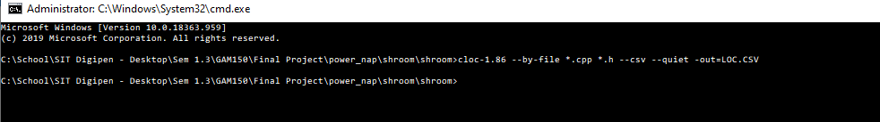

Step 5: There you have the file!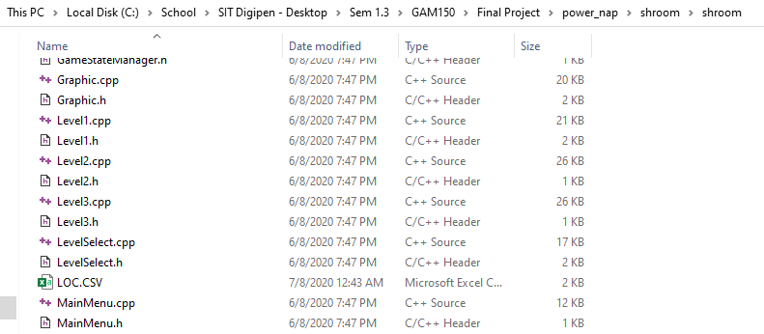

Step 6:

